📘 Introduction to UML Class Diagrams
2.X UML Class Diagram Overview
A UML Class Diagram is a structural diagram defined by the Unified Modeling Language (UML) standard. It represents the static structure of a system by modeling classes, their attributes, methods (operations), and relationships between classes.
In object-oriented system design, the class diagram serves as the foundational blueprint for defining system entities and their interactions. It is widely used during analysis and design phases to model domain structure before implementation.
A class diagram primarily consists of:
1. Classes
A class represents an entity in the system. It is depicted as a rectangle divided into compartments:
- Class Name
- Attributes
- Operations (optional)
In this project, only the class name and attributes are considered for code generation.

2. Attributes
Attributes define the properties of a class. Each attribute includes:
- Attribute name
- Data type
- Optional visibility modifier
Example:
Student

id : Integer
name : String
email : String

Attributes are used to generate:
- Database table columns
- Model properties in backend code

3. Associations
Associations represent relationships between classes. These may include:
- One-to-One (1:1)
- One-to-Many (1:*)
- Many-to-Many (:)
Associations are used to generate:
- Foreign key constraints
- Relationship mappings in backend logic

4. Inheritance (Generalization)
Inheritance defines a parent-child relationship between classes, where a subclass inherits attributes and behavior from a superclass.
In UML, this is represented by a directed arrow pointing to the parent class.
Inheritance may be optionally supported in later development iterations.

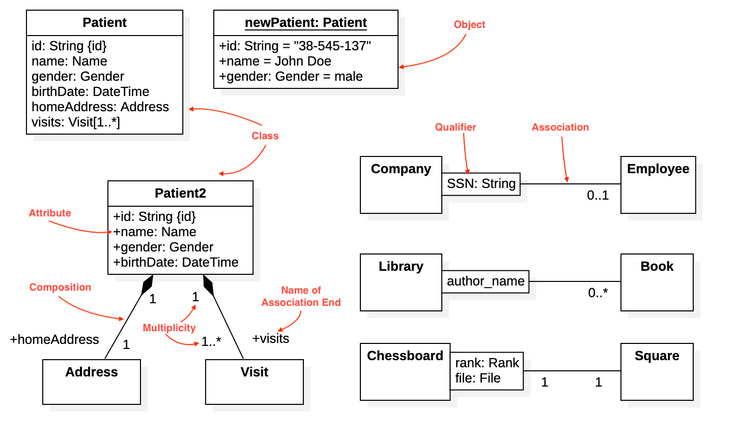

📄 XMI Structural Analysis Report
(Based on UML Class Diagram – StarUML XMI 2.x Export)

1️⃣ Model Information
Tool Used: StarUML
Export Format: UML 2.x (XMI)
File Name: model1.xml
Diagram Type: Class Diagram

2️⃣ Class Structure Analysis
🔹 Storage Tag
Classes are stored inside:
<packagedElement>
🔹 Identification Pattern
<packagedElement xmi:id="AAAAAAGcdbP3BmxmxKQ=" name="Student" visibility="public" isAbstract="false" isFinalSpecialization="false" isLeaf="false" xmi:type="uml:Class" isActive="false">🔹 Notes
- Class name stored in attribute: name
- To find – xmi:type="uml:Class"
- Unique identifier stored in: xmi:id

3️⃣ Attribute Structure Analysis
🔹 Storage Tag
Attributes are stored inside:
<ownedAttribute>
🔹 Identification Pattern
<ownedAttribute xmi:id="…." name="id" isStatic="false" isLeaf="false" type="int_id" isReadOnly="false" isOrdered="false" isUnique="false" xmi:type="uml:Property" aggregation="none" isDerived="false" isID="false"/>
🔹 Notes
- Types observed as: Direct / Reference / Mixed
- To find : xmi:type="uml:Property"
- Visibility stored in: visibility="public"
<packagedElement xmi:id="int_id" xmi:type="uml:DataType" name="int"/> Type identifier

4️⃣ Association Structure Analysis (If Present)
🔹 Storage Tag
<packagedElement xmi:type="uml:Association">
🔹 Identification Pattern (See model2)
<ownedMember xmi:id="AAAAAAGcdbs8x0SW9us=" name="has" visibility="public" xmi:type="uml:Association" isDerived="false">
🔹 Member Ends
Associations connect classes using:
memberEnd="id1 id2"
🔹 Observed Associations
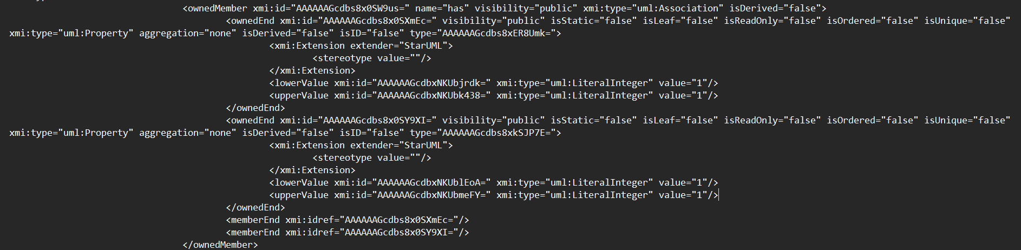
🔹 Multiplicity Pattern (If Found)
Multiplicity stored inside:
<ownedEnd>
<lowerValue>
<upperValue>
<ownedEnd>
<ownedEnd xmi:id="AAAAAAGcdbfxOG4G9SI=" visibility="public" isStatic="false" isLeaf="false" isReadOnly="false" isOrdered="false" isUnique="false" xmi:type="uml:Property" aggregation="none" isDerived="false" isID="false" type="AAAAAAGcdbfxN233fE8=">
The marked one is the id of the class at whose end the association is made .

5️⃣ Inheritance (Generalization) Structure (If Present)
🔹 Storage Tag
<generalization>
🔹 Identification Pattern
<generalization xmi:id="AAAAAAGcdbnAKxq7yTA=" visibility="public" xmi:type="uml:Generalization" specific="AAAAAAGcdbnAKhqveXE=" general="AAAAAAGcdbnAKBqiv8k="/>

🔹 Observed Generalizations
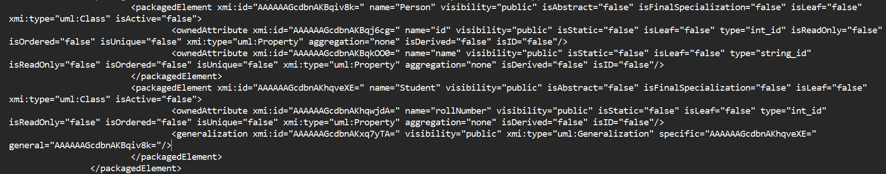
Specific = ”….” xmi:id of is the child
General = ”….” xmi:id is the parent
6️⃣ Namespace & Root Structure
Root tag observed as:
<uml:Model>
Namespace declarations:
xmlns:uml="..."
xmlns:xmi="..."
Notes:

7️⃣ Key observations
The details of association are given in the first class’ <packagedElement> block

8️⃣ Identified Parsing Risks
☐ Type references require ID resolution
☐ Associations stored separately from classes
☐ Multiplicity stored in nested tags
☐ Namespace prefix required for parsing

9️⃣ Final Mapping Blueprint for Parser
Extract Classes Using:
xmi:type="uml:Class"
Extract Attributes Using:
<ownedAttribute
Resolve Types Using:
type attribute → match with xmi:id
Extract Associations Using:
xmi:type="uml:Association"
Extract Inheritance Using:
<generalization>

